REPORT OF MARK PROTECTION COMMITTEE
August 2024 – June 2025
Membership and Structure
Members of the WSFS Mark Protection Committee (“MPC”) from August 2024 through June 2025 were as follows, with the expiration of membership listed in parentheses after their name: Judy Bemis (elected until 2026); Alan Bond (appointed by Seattle 2025 until 2027); Joni Dashoff (elected until 2026); Linda Deneroff (Secretary, elected until 2027); Donald E. Eastlake III (Chair, elected until 2027); David Ennis (appointed by Buffalo NASFiC 2024 until 2026); Olav Rokne (elected until 2027); Linda Ross-Mansfield (appointed by Pemmi-Con until 2025); Chen Shi (appointed by Chengdu 2023 until 2025); Kevin Standlee (elected until 2025); Alissa Wales (appointed by Glasgow until 2026); Mike Willmoth (elected until 2026); Nicholas Whyte (elected until 2025); and Ben Yalow (elected until 2025). Bruce Farr remains its appointed treasurer.
Worldcon Intellectual Property (“WIP”) is a California public benefit/non-profit corporation (also recognized as a 501(c)(3) tax-exempt charity by the U.S. Internal Revenue Service) controlled by the MPC that holds the MPC’s bank account and WSFS’s service marks. The current MPC Financial Report is appended at the end of this document. A report from the WSFS Marketing Committee (“WSFSMC”) is included as an appendix to this report. The WSFSMC is an advisory board of the MPC and is responsible for managing the WSFS websites (TheHugoAwards.org, Worldcon.org, NASFiC.org, and WSFS.org) and social media accounts on Facebook and other social media.
REPORT
The MPC proposed items of new business to the 2024 Glasgow WSFS Business Meeting which were adopted as follows:
1. The resolution to fund the MPC with US$1.00 per WSFS Worldcon member and with US$0.30 per member of non-Worldcon conventions sanctioned by WSFS from any surplus they may have. This was passed and supersedes the previously recommended donations.
2. The MPC’s second motion to require a license agreement between bidding and operating Worldcon committees and the MPC was passed and sent on to the Seattle WSFS BM for ratification. The WIP/MPC then created a Licensing Advisory Board to come up with a licensing agreement between WIP/MPC and individual committees. Members of this advisory board are Don Eastlake, Alan Bond, and Judy Bemis as MPC-appointed members, Jesi Lipp as BM Chair, and the chairs (or their appointees) of the two seated Worldcons (i.e., Kathy Bond for the Seattle Worldcon and Joyce Lloyd or appointee for the Los Angeles Worldcon.
3. The Glasgow WSFS BM also passed the MPC’s motion creating BM selected Hugo Administration Subcommittee members and Site Selection special tellers to monitor those functions and report to the BM, and that, too, was sent on to Seattle for ratification.
4. Finally, the WSFS BM did the same for a motion to specify MPC procedures.
Detailed information on these motions can be found in the 2024 Glasgow WSFS BM minutes and in the Business Passed on to Seattle documents.
The Worldcon.fr domain was transferred to Nicholas Whyte, who renewed it through December 31, 2027. Thank you, Nicholas.
Probably the biggest issue we dealt with this year was negotiating with Warner Brothers Studios for the use of fictitious Hugo Awards to be used in the background of a new film (current working title Ghostwriter, directed by J.J. Abrams), to ensure that the word “Replica” appears on any such Hugo Award props. (They had originally requested original rockets to appear in the film, but they were unable to obtain any for the years they wanted.)
Our website SSL certificates have been updated to run through June 2026.
In December 2024, we received registration for our trademark “Worldcon” in Australia! We still plan to obtain a trademark there for “Hugo Award” but are working our way around a stumbling block. In the meantime, in England and Europe we renewed our trademarks for Hugo Award, Worldcon, and our rocket design. Our European attorneys and the governmental fees are quite expensive, but they agreed to us paying £600 a year for the next 10 years instead of requiring payment in full upfront, which would have depleted our funds.
Also in December, the MPC/WIP granted Sara Chen’s request (with caveats) to name a new bilingual fanzine from SFW (Science Fiction World, the most influential SF publishing house in China) “Hugo News”. The fanzine would be free and designed to keep Chinese fandom updated with the Hugo Award news, which is the task no one was doing sustainably there. The MPC requested that they (a) use the full term “Hugo Award” (per our agreement with Hugo Boss), (b) include a prominent statement near the top of the first page that the magazine is not a production of the World Science Fiction Society or any World Science Fiction Convention, (c) that the official site of the Hugo Awards is https://www.thehugoawards.org/, and (d) include the statement “World Science Fiction Society”, “WSFS”, “World Science Fiction Convention”, “Worldcon”, “NASFiC”, “Lodestar Award”, “Hugo Award”, the Hugo Award Logo, and the distinctive design of the Hugo Award Rocket are service marks of Worldcon Intellectual Property, a California non-profit corporation managed by the Mark Protection Committee of the World Science Fiction Society, an unincorporated literary society. You can contact the WSFS Mark Protection Committee at mpc@wsfs.org.”
The MPC is still pursuing that thehugoawards.com and thehugoawards.org, that were held by Deb Geisler for the MPC/WSFS. Her widower, Mike Benveniste has offered to transfer these names to the control of the MPC at the Glasgow Worldcon, but he had contracted COVID, and it did not happen. The “.com” version of the name was “parked” at the registrar, so it looked like someone was squatting on it and wanted to sell it. Don pursued acquiring this name as approved by the MPC. It looked like we would be out the $99 domain name broker’s fee but that was refunded.

Domain Names
Domain | Domain Agent | Handle to Renew | Renewal Date
WSFS.org | Worldcon Intellectual Property | GANDI.net – 8 years | 2028-06-14
Worldcon.org | Worldcon Intellectual Property | GANDI.net – 8 years | 2028-08-02
Hugo.org | Worldcon Intellectual Property | GANDI.net – 9 years | 2028-08-31
HugoAward.org | Worldcon Intellectual Property | GANDI.net – 9 years | 2033-05-03
Worldcon.com | Worldcon Intellectual Property | GANDI.net – 9 years | 2028-10-09
Worldcon.co.uk | Worldcon Intellectual Property | GANDI.net – 9 years | 2028-10-17
Worldcon.org.uk | Worldcon Intellectual Property | GANDI.net – 9 years | 2028-10-17
Worldcon.uk | Worldcon Intellectual Property | GANDI.net – 9 years | 2031-06-17
NASFiC.org | Worldcon Intellectual Property | GANDI.net – 9 years | 2029-05-09
wsfs.us | Donald Eastlake | godaddy.com | 2028-06-20
wsfs.info | Donald Eastlake | godaddy.com | 2027-07-25
worldcon.us | Donald Eastlake | godaddy.com | 2028-08-12
worldcon.info | Donald Eastlake | godaddy.com | 2027-07-05
worldcons.org | Donald Eastlake | godaddy.com | 2026-01-18
worldcon.fr | Nicholas Whyte | GANDI.net | 2027-12-31
U.S. Marks
Mark | Action | Renewal Dates
World Science Fiction Convention  Reg. No 1283681 | Section 8, Section 9 | 6/26/2033-6/26/2034
Worldcon  Reg. No. 1283680 | Section 8, Section 9 | 6/26/2033-6/26/2034
World Science Fiction Society  Reg. No. 1284719 | Section 8, Section 9 | 7/3/2033-7/3/2034
WSFS  Reg. No. 1286562 | Section 8, Section 9 | 7/17/2033-7/17/2034
The Hugo Award  Reg. No. 1287322 | Section 8, Section 9 | 7/24/2033-7/24/2034
3D Rocket Mark  Reg. No. 4620505 | Section 8, Section 9 | 10/14/2033-10/16/2033
Rocket Mark  Reg. No. 4320959 | Section 8, Section 9 | 4/16/2032-4/18/2033
NASFiC  Reg. No. 3647140 | Section 8, Section 9 | 6/30/2028-6/29/2029
Lodestar Award  Reg. No. 7246730 | Section 8, Section 9 | 12/19/2028-12/19/2029
Rocket Mark  (Miscellaneous Design) | Section 8, Section 15 | 4/16/2028-4/15/2029
UK Marks
Mark | Class | Expiry Dates | Trademark No.
Worldcon | Class 16, 35, 41 | 2035/06/17 | 014277016
Hugo Award | Class 9, 16, 41 | 2035/06/18 | 014278519
The Hugo Award Logo | Class 16, 35, 41 | 2035/06/21 | 014270748
EU Marks
Mark | Class | Expiry Dates | Trademark No.
Worldcon | Class 16, 35, 41 | 2035/06/18 | 014277016
Hugo Award | Class 9, 16, 41 | 2035/06/18 | 014278519
The Hugo Award Logo | Class 16, 35, 41 | 2035/06/22 | 014270748
Australian Marks
Mark | Class | Acceptance After | Trademark No.
Worldcon | Class 41 | 2025/09/15 | 014277016

Mark Protection Committee/WIP Financial Report
All U.S. Dollars
Period Ending May 31, 2025
 | Date | Deposits | Payments | Check No. | Account  Balance
Book Balance end of 2024 fiscal reporting | 2024-07-01 |  |  |  | $15,759.47
Analysis Bank Service Charge | 2024-07-31 |  | $52.00 |  | $15,707.47
Esther Horwich Atty, Hugo and Rocket TM Renewal | 2024-09-10 |  | $1,425.00 | 1136 | $14,282.47
Bruce Farr, Reimb, Goja Haines Australia Worldcon reg review | 2024-09-17 |  | $485.00 | 1137 | $13,797.47
Kevin Standlee, Reimb, Domain Hosting | 2024-10-10 |  | $98.40 | 1138 | $13,699.07
Deposit, 2024 Buffalo NASFiC Dues | 2024-10-28 | $161.25 |  |  | $13,860.32
Esther Horwich, Atty, USPTO correspondence | 2024-10-28 |  | $120.00 |  | $13,740.32
Pairdomains Debit | 2025-01-03 |  | $3.00 |  | $13,737.32
Glasgow 2024 Worldcon dues | 2025-01-28 | $8,828.00 |  |  | $22,565.32
Pairdomains Debit | 2025-02-04 |  | $3.00 |  | $22,562.32
Bank Service Charge | 2025-02-14 |  | $28.00 |  | $22,534.32
Pairdomains Debit | 2025-03-04 |  | $3.00 |  | $22,531.32
California Meridian, D&O Insurance to 2-28-26 | 2025-03-10 |  | $1,211.00 |  | $21,320.32
Pairdomains Debit | 2025-04-02 |  | $3.00 |  | $21,317.32
Pairdomains Debit | 2025-05-02 |  | $3.00 |  | $21,314.32
Book Balance May 31, 2025 |  |  |  |  | $21,314.32
—Bruce Farr
WSFS Hugo Awards Marketing Committee
August 2024-June 2025
The WSFS Marketing Committee (“WSFSMC”) members are Linda Deneroff (Chair), Jerry Kaufman, Craig Miller, Chris Rose, Kevin Standlee, and Jo Van Ekeren. The WSFSMC was established by the WSFS Mark Protection Committee, and its chair and members are appointed by the MPC annually.
The WSFSMC continues to work with Worldcon committees to support the marketing of the Hugo Awards, to handle inquiries from the press regarding the Awards as needed, to maintain TheHugoAwards.org, including the list of past finalists and winners, and archiving the “Section 3.11.4” reports of nomination and voting information issued by Hugo Award administrators, and to maintain the WSFS.org, Worldcon.org, and NASFiC.org websites and answer general queries submitted through those sites.
The WSFSMC will continue to cooperate with Worldcon committees so that we can update the Hugo Awards web site at the first opportunity after the awards are announced as well as to use the @TheHugoAwards BlueSky feed, Hugo Awards Facebook page, and other social media to publicize the announcements of the winners in each category.
thehugoawards.org
Views per Month, June 1, 2024-May 17, 2025
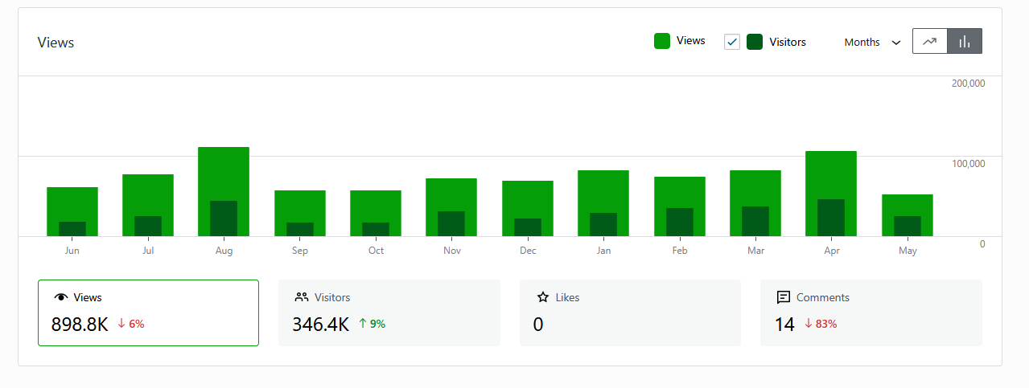
thehugoawards.org
Most Requested Pages/Posts and Referrers, June 1, 2024-May 17, 2025
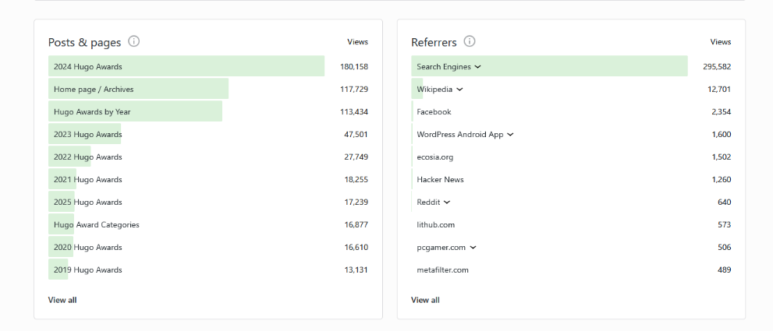
Thehugoawards.org
Top Page Views per Country, June 1, 2024-May 17, 2025
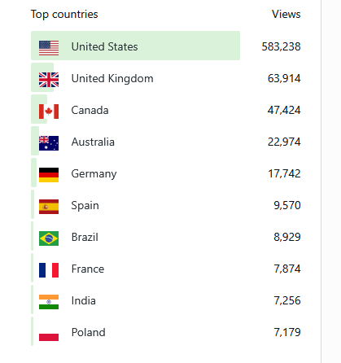
We continue to attempt to gather all the recordings of past Hugo Awards ceremonies (including any made before online posting of such recordings was possible or common) and to put copies of them in the Worldcon Events YouTube channel. We are still looking for a copy of the 2017 Hugo Awards ceremony recording that was deleted when the 2017 Worldcon’s YouTube channel was deleted. If anyone has a copy of the 2017 ceremony video that they can provide us, we will upload it to the Worldcon Events channel.
We maintain the list of seated, future, and recent Worldcons and the lists of bids for future conventions to the best of our knowledge. Multiple members of the committee have the credentials for the web sites. Bandwidth and disk space usage for the web sites we manage were within the allowances for our account. We may see peak loads around the time of the winner announcements, and will work with our hosting provider to minimize extra charges, which are borne by the Mark Protection Committee.
We continue to field inquiries directed to Worldcon.org and TheHugoAwards.org, forwarding them to the current Worldcon or Mark Protection Committee, as necessary.

