REPORT OF MARK PROTECTION COMMITTEE
July 2025 – June 2026
Membership and Structure
Members of the WSFS Mark Protection Committee (“MPC”) from July 2025 through June 2026 were as follows, with the expiration of membership listed in parentheses after their name: Kayla Allen (appointed by Montréal until 2029); Judy Bemis (elected until 2026); Alan Bond (elected until 2028); Warren Buff (Chair, appointed by Seattle until 2027); Joni Dashoff (elected until 2026); Linda Deneroff (Secretary, elected until 2027); Donald E. Eastlake III (elected until 2027); David Ennis (appointed by Buffalo NASFiC 2024 until 2026); Olav Rokne (elected until 2027); Chris Rose (elected until 2028); Randall Shepherd (Vice Chair, appointed by LACon V until 2028); Alissa Wales (appointed by Glasgow until 2026); Nicholas Whyte (elected until 2028); Mike Willmoth (elected until 2026). Bruce Farr (Treasurer, was appointed ex officio until 2026). Don was originally elected chair for the 2025-2026 term, but the MPC later elected Warren to serve in that office instead.
Worldcon Intellectual Property (“WIP”) is a California public benefit/non-profit corporation (also recognized as a 501(c)(3) tax-exempt charity by the U.S. Internal Revenue Service) controlled by the MPC that holds the MPC’s bank account and WSFS’s service marks. The current MPC Financial Report is appended at the end of this document. A report from the WSFS Marketing Committee (“WSFSMC”) is included as an appendix to this report. The WSFSMC is an advisory board of the MPC and is responsible for managing the WSFS websites (TheHugoAwards.org, Worldcon.org, NASFiC.org, and WSFS.org) and social media accounts on Facebook and other social media.
REPORT
In 2025, an advisory board was created by the MPC consisting of MPC members Don Eastlake, Alan Bond, and Judy Bemis, as well as Jesi Lipp (2025 BM Chair), Kathy Bond 2025 Worldcon chair, and Joyce Lloyd (2026 Worldcon chair), to write a new Licensing Agreement to present to Worldcon bids beginning with the 2028 bids. The Licensing Agreement was created in 2026, and the two 2028 bids (Brisbane and Nuremberg) have signed the agreement.
We are once again updating our domains and plan to move them from Gandi to Porkbun as they expire. Chris reported that Porkbun is cheaper and offers more benefits.
We are still working with our attorneys to register our trademark for “Hugo Award” in Australia.
Domain Names
Domain | Domain Agent | Handle to Renew | Renewal Date
WSFS.org | Worldcon Intellectual Property | GANDI.net – 8 years | 2028-06-14
Worldcon.org | Worldcon Intellectual Property | GANDI.net – 8 years | 2028-08-02
Hugo.org | Worldcon Intellectual Property | GANDI.net – 9 years | 2028-08-31
HugoAward.org | Worldcon Intellectual Property | GANDI.net – 9 years | 2033-05-03
Worldcon.com | Worldcon Intellectual Property | GANDI.net – 9 years | 2028-10-09
Worldcon.co.uk | Worldcon Intellectual Property | GANDI.net – 9 years | 2028-10-17
Worldcon.org.uk | Worldcon Intellectual Property | GANDI.net – 9 years | 2028-10-17
Worldcon.uk | Worldcon Intellectual Property | GANDI.net – 9 years | 2031-06-17
NASFiC.org | Worldcon Intellectual Property | GANDI.net – 9 years | 2029-05-09
wsfs.us | Donald Eastlake | godaddy.com | 2028-06-20
wsfs.info | Donald Eastlake | godaddy.com | 2027-07-25
worldcon.us | Donald Eastlake | godaddy.com | 2028-08-12
worldcon.info | Donald Eastlake | godaddy.com | 2027-07-05
worldcons.org | Donald Eastlake | godaddy.com | 2026-01-18
worldcon.fr | Nicholas Whyte | GANDI.net | 2027-12-31
U.S. Marks
Mark | Action | Renewal Dates
World Science Fiction Convention  Reg. No 1283681 | Section 8, Section 9 | 6/26/2033-6/26/2034
Worldcon  Reg. No. 1283680 | Section 8, Section 9 | 6/26/2033-6/26/2034
World Science Fiction Society  Reg. No. 1284719 | Section 8, Section 9 | 7/3/2033-7/3/2034
WSFS  Reg. No. 1286562 | Section 8, Section 9 | 7/17/2033-7/17/2034
The Hugo Award  Reg. No. 1287322 | Section 8, Section 9 | 7/24/2033-7/24/2034
3D Rocket Mark  Reg. No. 4620505 | Section 8, Section 9 | 10/14/2033-10/16/2033
Rocket Mark  Reg. No. 4320959 | Section 8, Section 9 | 4/16/2032-4/18/2033
NASFiC  Reg. No. 3647140 | Section 8, Section 9 | 6/30/2028-6/29/2029
Lodestar Award  Reg. No. 7246730 | Section 8, Section 9 | 12/19/2028-12/19/2029
Rocket Mark  (Miscellaneous Design) | Section 8, Section 15 | 4/16/2028-4/15/2029
UK Marks
Mark | Class | Expiry Dates | Trademark No.
Worldcon | Class 16, 35, 41 | 2035/06/17 | 014277016
Hugo Award | Class 9, 16, 41 | 2035/06/18 | 014278519
The Hugo Award Logo | Class 16, 35, 41 | 2035/06/21 | 014270748
EU Marks
Mark | Class | Expiry Dates | Trademark No.
Worldcon | Class 16, 35, 41 | 2035/06/18 | 014277016
Hugo Award | Class 9, 16, 41 | 2035/06/18 | 014278519
The Hugo Award Logo | Class 16, 35, 41 | 2035/06/22 | 014270748
Australian Marks
Mark | Class | Acceptance After | Trademark No.
Worldcon | Class 41 | 2025/09/15 | 014277016

Mark Protection Committee/WIP Financial Report
All U.S. Dollars
Period Ending April 30, 2026
 | Check No. | Date | Deposits | Payments | Account  Balance
Book Balance June 1, 2025 |  |  |  |  | $21,314.32
Deposit, Interest |  | 5/31/2025 | $1.51 |  | $21,315.83
Pair Domains |  | 5/15/2025 |  |  | $21,220.88
Foot Anstey LLP EU/GB Trademarks (incl$45 Wire Fee) |  | 6/27/2025 |  | $94.95 | $16,120.11
Deposit, Interest |  | 6/30/2025 | $45.20 | $5,100.77 | $16,165.31
Pair Domains |  | 6/2/2025 |  |  | $16,133.75
Vistaprint (checks) |  | 6/2/2025 |  | $31.56 | $16,105.19
Donald Eastlake, Reimb Domain Renewals |  | 05/31/2025 |  | $28.56 | $15,765.07
Pair Domains |  | 7/1/2025 |  | $340.12 | $15,704.95
Deposit, Interest |  | 7/31/2025 | $46.86 | $60.12 | $15,751.81
Pair Domains |  | 8/2/2025 |  |  | $15,748.81
Deposit, Interest |  | 8/31/2025 | $45.50 | $3.00 | $15,794.31
Pair Domains |  | 9/1/2025 |  |  | $15,791.31
Foot Anstey LLP EU/GB Trademarks (incl$45 Wire Fee) |  | 9/17/2025 |  | $3.00 | $13,638.21
Gandi.net Charges | 1303 | 9/17/2025 |  | $2,153.10 | $13,413.05
ilGhf Ip Ppty Ltd Australian Trademarks Legal (incl$25 wire fee) |  | 9/18/2025 |  | $225.16 | $12,321.05
Pair Domains |  | 10/1/2025 |  | $1,092.00 | $12,122.69
State of California (filings) | 50 | 10/17/2025 |  | $198.36 | $12,097.69
Deposit, Interest |  | 9/30/2025 | $0.01 | $25.00 | $12,097.70
Deposit, Interest |  | 9/30/1995 | $40.81 |  | $12,138.51
Deposit, Interest |  | 10/31/2025 | $37.30 |  | $12,175.81
Pair Domains |  | 11/1/2025 |  |  | $12,172.81
Deposit, Seattle Worldcon |  | 11/9/2025 | $8,045.00 | $3.00 | $20,217.81
State of California (filings) | 1305 | 11/28/2025 |  |  | $20,197.81
Deposit, Interest |  | 11/30/2025 | $36.22 | $20.00 | $20,234.03
Pair Domains |  | 12/1/2025 |  |  | $20,231.03
Deposit, Interest |  | 12/31/2025 | $0.01 | $3.00 | $20,231.04
Deposit, Interest |  | 12/31/2025 | $37.54 |  | $20,268.58
Pair Domains |  | 11/1/2026 |  |  | $20,265.58
Deposit, Interest |  | 1/31/2026 | $37.67 | $3.00 | $20,303.25
Pair Domains |  | 2/1/2026 |  |  | $20,300.25
State of California (filings) |  | 2/13/2026 |  | $3.00 | $20,275.25
Ghf Ip Ppty Ltd Australian Trademarks Legal (incl$25 wire fee) |  | 2/13/2026 |  | $25.00 | $18,177.75
Deposit, Interest |  | 2/28/2026 | $34.14 | $2,097.50 | $18,211.89
Pair Domains |  | 3/1/2026 |  |  | $18,208.89
California Meridian, Board D&O Insurance |  | 3/4/2026 |  | $3.00 | $16,997.89
Deposit, Interest |  | 3/31/2026 | $0.01 | $1,211.00 | $16,997.90
Deposit, Interest |  | 3/31/2026 | $37.91 |  | $17,035.81
Pair Domains |  | 4/1/2026 |  |  | $17,032.81
Deposit, Interest |  | 4/30/2026 | $36.81 | $3.00 | $17,069.62
Book Balance April 30, 2026 |  |  |  |  | $17,069.62

Account Balance April 30, 2026
Checking, Redwood CU | $5,532.12
Share Account, Redwood CU | 100.03
Share Certification, Redwood CU | 11,437.47
Book Balance April 30, 2026 | $17,069.62

—Bruce Farr
WSFS Hugo Awards Marketing Committee
June 2025-May 2026
The WSFS Marketing Committee (“WSFSMC”) members are Linda Deneroff (Chair), Jerry Kaufman, Craig Miller, Chris Rose, Kevin Standlee, and Jo Van Ekeren. The WSFSMC was established by the WSFS Mark Protection Committee, and its chair and members are appointed by the MPC annually.
The WSFSMC continues to work with Worldcon committees to support the marketing of the Hugo Awards, to handle inquiries from the press regarding the Awards as needed, to maintain TheHugoAwards.org, including the list of past finalists and winners, and archiving the “Section 3.11.4” reports of nomination and voting information issued by Hugo Award administrators, and to maintain the WSFS.org, Worldcon.org, and NASFiC.org websites and answer general queries submitted through those sites.
The WSFSMC will continue to cooperate with Worldcon committees so that we can update the Hugo Awards web site at the first opportunity after the awards are announced as well as to use the @TheHugoAwards BlueSky feed, Hugo Awards Facebook page, and other social media to publicize the announcements of the winners in each category.
thehugoawards.org
Views per Month
June 1, 2025-May 24, 2026
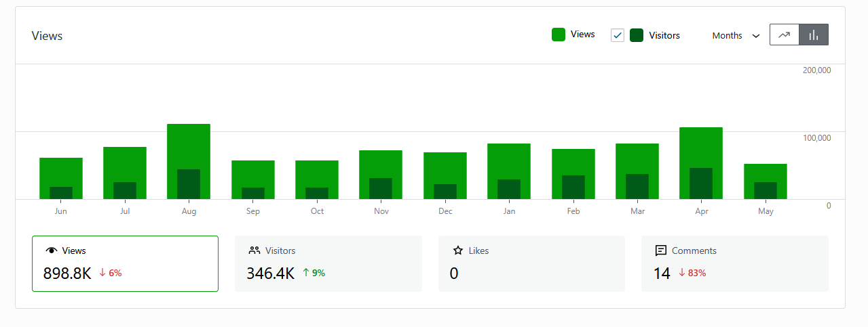
thehugoawards.org
Most Requested Pages/Posts and ReferrersJune 1, 2025-May 24, 2026
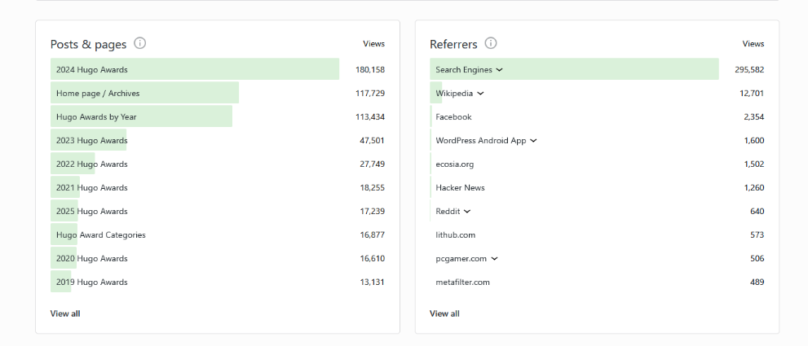
Thehugoawards.org
Top Page Views per Country
June 1, 2025-May 24, 2026
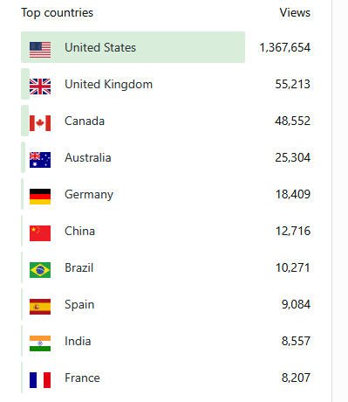
We continue to attempt to gather all the recordings of past Hugo Awards ceremonies (including any made before online posting of such recordings was possible or common) and to put copies of them in the Worldcon Events YouTube channel. We are still looking for a copy of the 2017 Hugo Awards ceremony recording that was deleted when the 2017 Worldcon’s YouTube channel was deleted. If anyone has a copy of the 2017 ceremony video that they can provide us, we will upload it to the Worldcon Events channel.
We maintain the list of seated, future, and recent Worldcons and the lists of bids for future conventions to the best of our knowledge. Multiple members of the committee have the credentials for the web sites. Bandwidth and disk space usage for the web sites we manage were within the allowances for our account. We may see peak loads around the time of the winner announcements and will work with our hosting provider to minimize extra charges, which are borne by the Mark Protection Committee.
We continue to field inquiries directed to Worldcon.org and TheHugoAwards.org, forwarding them to the current Worldcon or Mark Protection Committee, as necessary.

